LIST OF PRACTICALS
- To Study Basic Network command and Network configuration commands .
- Ping :- Checks the connectivity between two devices by sending ICMP echo requests
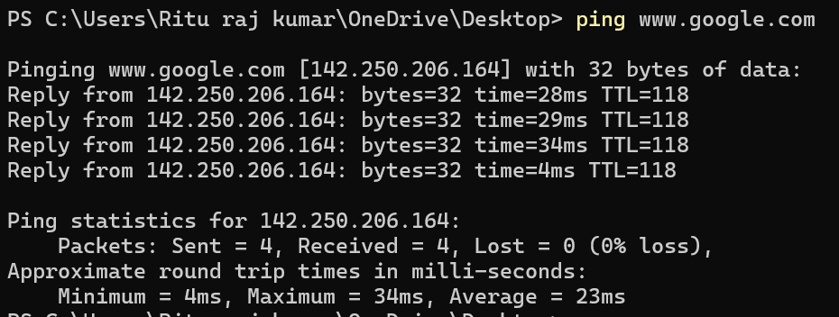
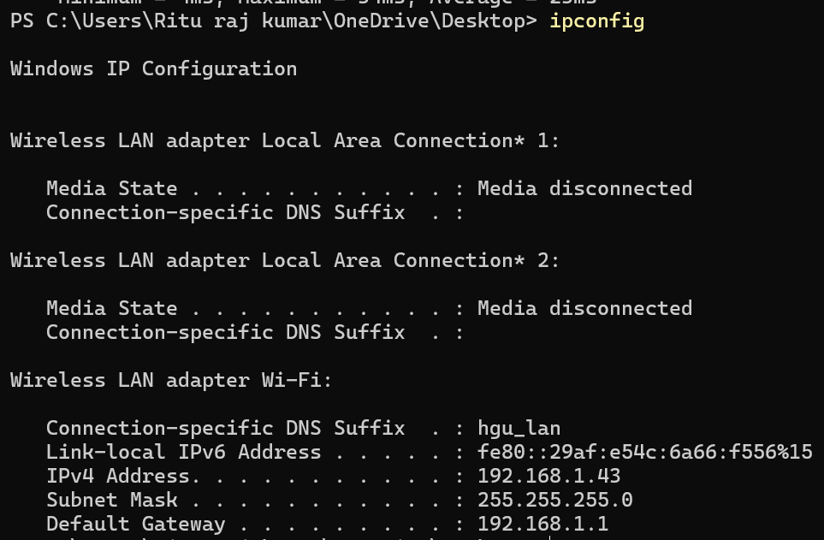
- Ipconfig :- Displays network configuration details.

- tracert :– Shows the path that packets take to reach the destination.
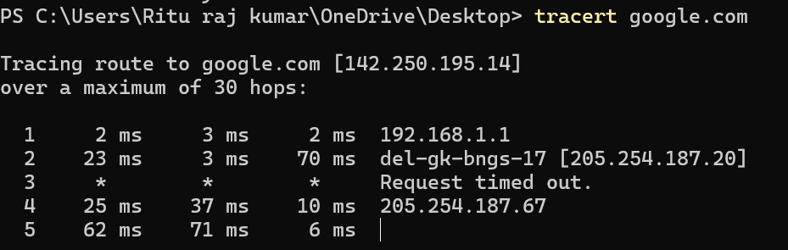
- netstat – Displays network statistics and active connections.
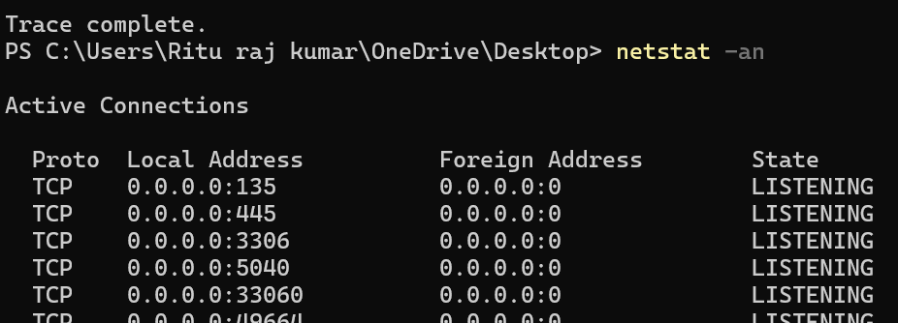
- nslookup – Finds the IP address associated with a domain name.
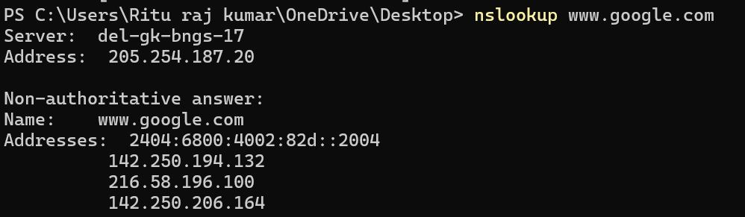

2. To Study and perform PC to PC communication.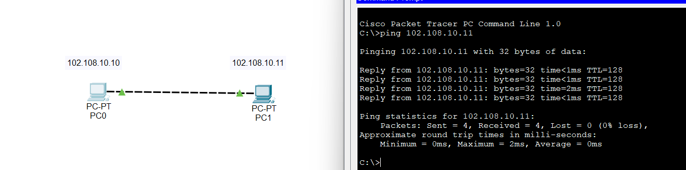
3. Create a Network Using Bluetooth –(Piconet / Scatternet) .
4. To create Star Topology using Hub and Switch.
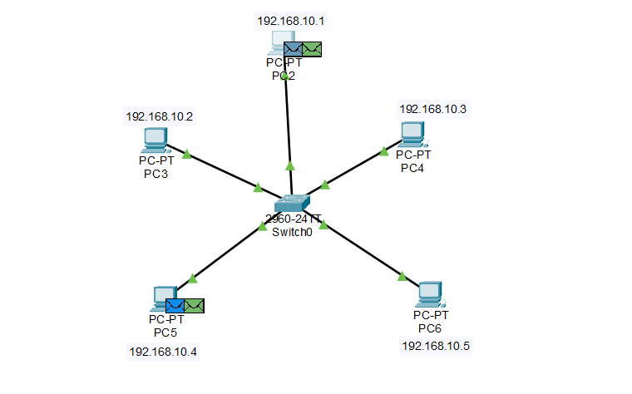
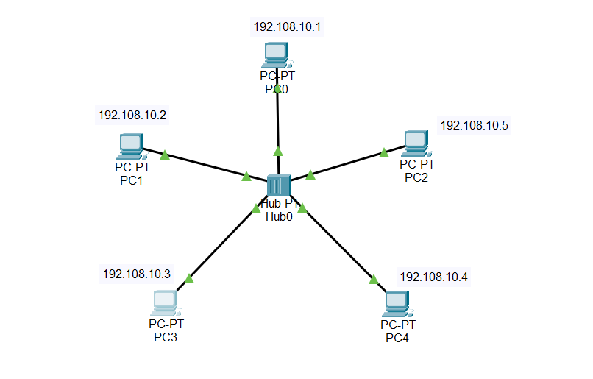
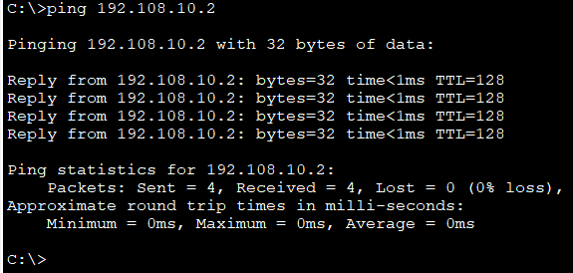
5. To Create Bus , Ring , Tree , Hybrid , Mesh Topologies .
BUS TOPOLOGY
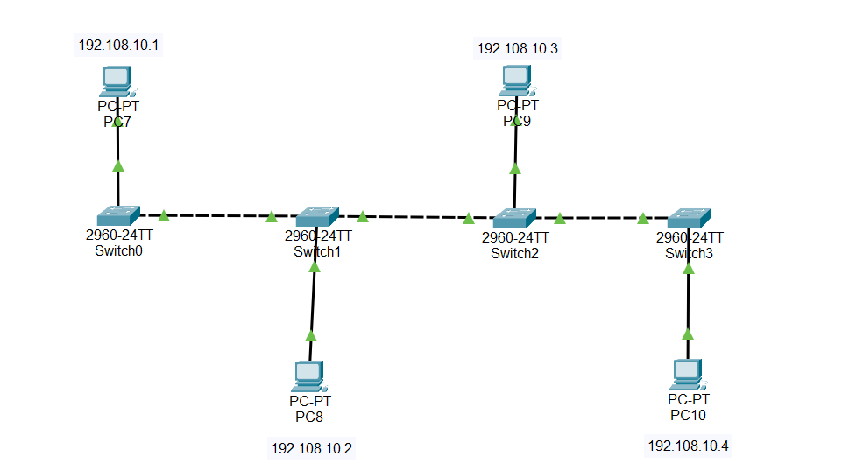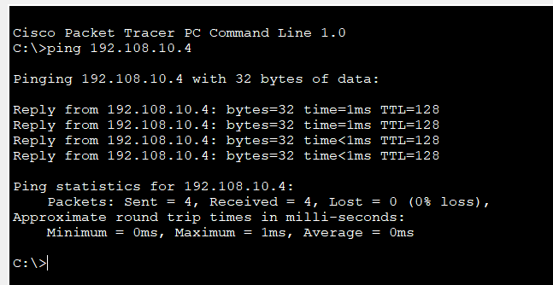

RING TOPOLOGY

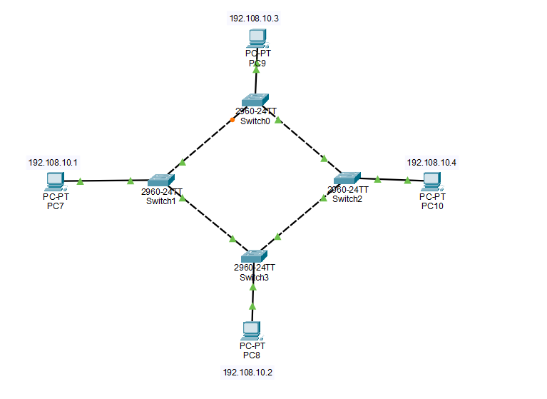

TREE TOPOLOGY
